**Unit 1: Animal Behavior & Natural Selection Chapters: 51, 22, 2, 3, 4, 5**

**Key Concepts**

* Recognize and explain the wealth of evidence that supports evolution
* Understand the points of Darwin’s theory
* Understand Evolutionary fitness
* Response to information and communication are essential for natural selection
* Biological molecules have specific roles in cells
* The components of bio-polymers and their sequence determine the properties of the molecule

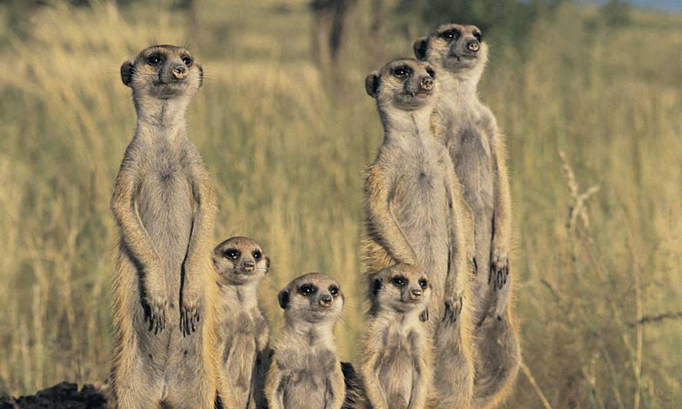

**Key Terms:**

Abiotic factor

Adaptation

Adaptive radiation

Amino acid

Amphipathic

Analogous structures

Biological clock

Biological Rhythm

Carbohydrate

Carbon

Circadian Rhythm

Coevolution

Condensation

Convergent evolution

Courtship

Crepuscular

Darwin

Denaturation

Disaccharide

Diurnal Rhythm

Divergent evolution

Dormancy

Environmental cue

Environmental cycle

Evolution

Fitness

Fixed action pattern

Fossils

Fossil record

Genetic variation

Habituation

Hibernation

Homologous structures Hydrogen bond

Hydrolysis

Imprinting

Innate

Lipid

Macromolecule

Migration

Monomer

Monosaccharide

Nitrogen

Natural selection

Navigation

**Essential Knowledge:**

**Natural Selection and Evolution (1.A.1)**

* Briefly describe Darwin’s theory of **natural selection** and its significance. Understand the terms **adaptation** and **evolutionary fitness**.
* Evaluate evidence to qualitatively and quantitatively investigate the role of natural selection in **evolution.**
* Explain the main points of Darwin’s Theory
* Understand the principals that govern natural selection.

**The Role of Variation (1.A.2)**

* Describe the role of **genetic variation** in providing the raw materials on which natural selection can act. Use specific examples, e.g. sickle cell disease, to relate phenotypic variation to fitness.
* Describe and evaluate examples of genetic change in real populations over time. Examples include peppered moths in the UK, sickle cell disease, &/or DDT resistance in insects.
* Describe the impact of human activity on variation in other species. Examples could include **artificial selection** in crops or livestock, or antibiotic misuse creating a selective environment for resistance.
* Explain how organisms with similar **morphologies** or DNA sequences may be closely related.
* Understand the differences between **homologous** and **analogous** structures. Be able to give examples of each.

**Animal Behavior (3.E, 4.A, 4.B, 4.C)**

* Distinguish between **innate** and **learned behavior**
* Describe examples of innate and learned behaviors and the adaptive role of the behavior in each case. Examples include taxes (sing. **Taxis**), Kineses (sing. **Kinesis**). **Imprinting**, **habituation, fixed action patterns**, **operant conditioning** and **classical conditioning**.
* Distinguish between **homing** and **migration**. Explain the adaptive value of homing and its dependence on environmental cues. Discuss the role of navigation in migratory and homing behavior in animals.
* Describe and explain **diurnal**, **nocturnal** and **crepuscular** activity patterns.
* Using examples, describe and explain how animals synchronize physiological processes with environmental cycles as cues. Examples include **circadian rhythms**, nocturnal and diurnal activity patterns, and seasonal responses such as breeding, **hibernation**, and **migration**.

**Key Terms:**

Non-polar

Nucleic acid

Nucleotide

Population

Primordial environment

Peptide bond

Phospholipid

Phosphorus

Polar

Polymer

Polysaccharide

Protein

Sexual selection

Species

Vestigial Organs

**Animal Communication (3.E.1, 3.E.3)**

* Explain how animals communicate information about changes in the environment and explain the survival value of such behaviors. Examples include bee dances, bird songs, territorial marking, pack behavior, and predator warning.
* Explain the survival value of responding appropriately to communicated information, e.g. in parent-offspring behaviors, in courtship, and in migration and foraging behaviors.
* Explain how cooperative behaviors, e.g. herd behavior, increase individual fitness and population survival

**Role of Biological Macromolecules (2.A.3, 4.A.1)**

* Using examples, explain the dependence of living systems on the properties of water. Relate the properties of water to its structure including it’s **polar** nature.
* Identify the common elements found in organisms and give examples of where each of these elements occur in cells
* Describe the basic roles of **carbohydrates**, **amino acids**, **proteins**, **lipids**, **nucleotides** and **nucleic acids**. Recognize simple tests to detect these molecules in food.
* Distinguish between **momomers** and **polymers**. Describe the range of **macromolecules** produced by cells and explain how these are used.
* Describe the synthesis of macromolecules by **condensation** and their breakdown by **hydrolysis**. Identify the bonds broken and formed in each case.
* With reference to nucleic acids and proteins explain how the properties of a polymer and determined by its component monomers. For proteins explain the 4 levels of organization.
* Explain the biological significance of the **amphipathic** nature of some lipids, e.g. **phospholipids**, cholesterol.
* Using examples, explain how the properties of **polysaccharides** are determined by the monomers present and the nature of the bonds between them.